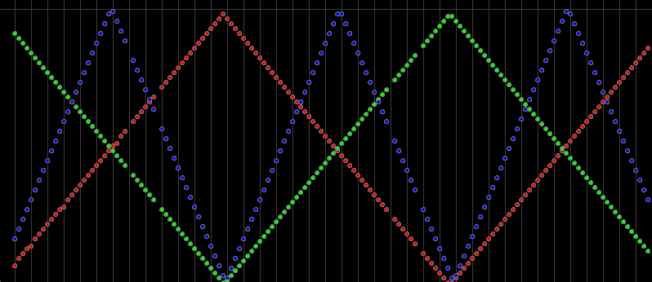**Current Settings as Shipped**:

**112**

**ANGLE**

**TIME:**

**0**

**TRUELY = GREEN** **JEMMA = RED**  **BOY = BLUE**

POS_X_MAX

POS_X_MIN

ANGLE

TIME

PHASE_OFFSET

PAUSE_DURATION

CHANGE_DURATION

**CONTROL SETTINGS VISUALIZED:**